Capstone_Project – 2
Azure DevOps CI Pipeline for Customer Management System
Part 1 – Agile Planning
Epic
Develop a Customer Management System for a Retail Company
Description:
Develop a Python-based application that enables users to manage customer records by adding, viewing, updating, and deleting customer information.

Feature 1: Customer Registration
User Story 1
As a user, I want to add new customer details so that customer information can be stored.
Tasks
- Create the Customer class.
- Implement the Add Customer functionality.
- Validate customer input.
- Test customer creation.

Feature 2: Customer Information Management

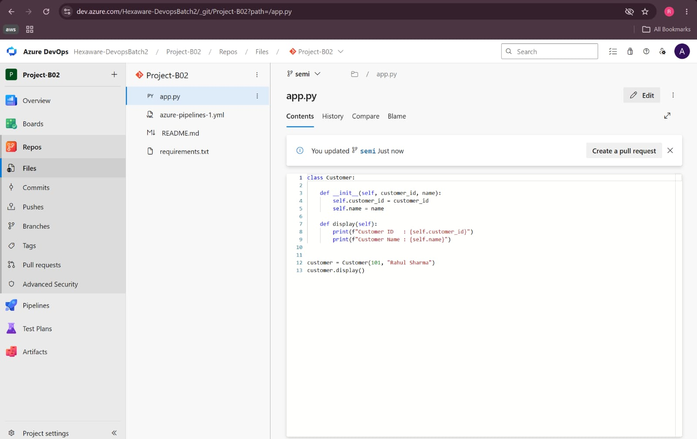

User Story 2
As a user, I want to view customer details so that I can access stored information.
Tasks
- Implement the View Customer functionality.
- Display customer details.
- Test the view operation.

Feature 3: Customer Update and Delete

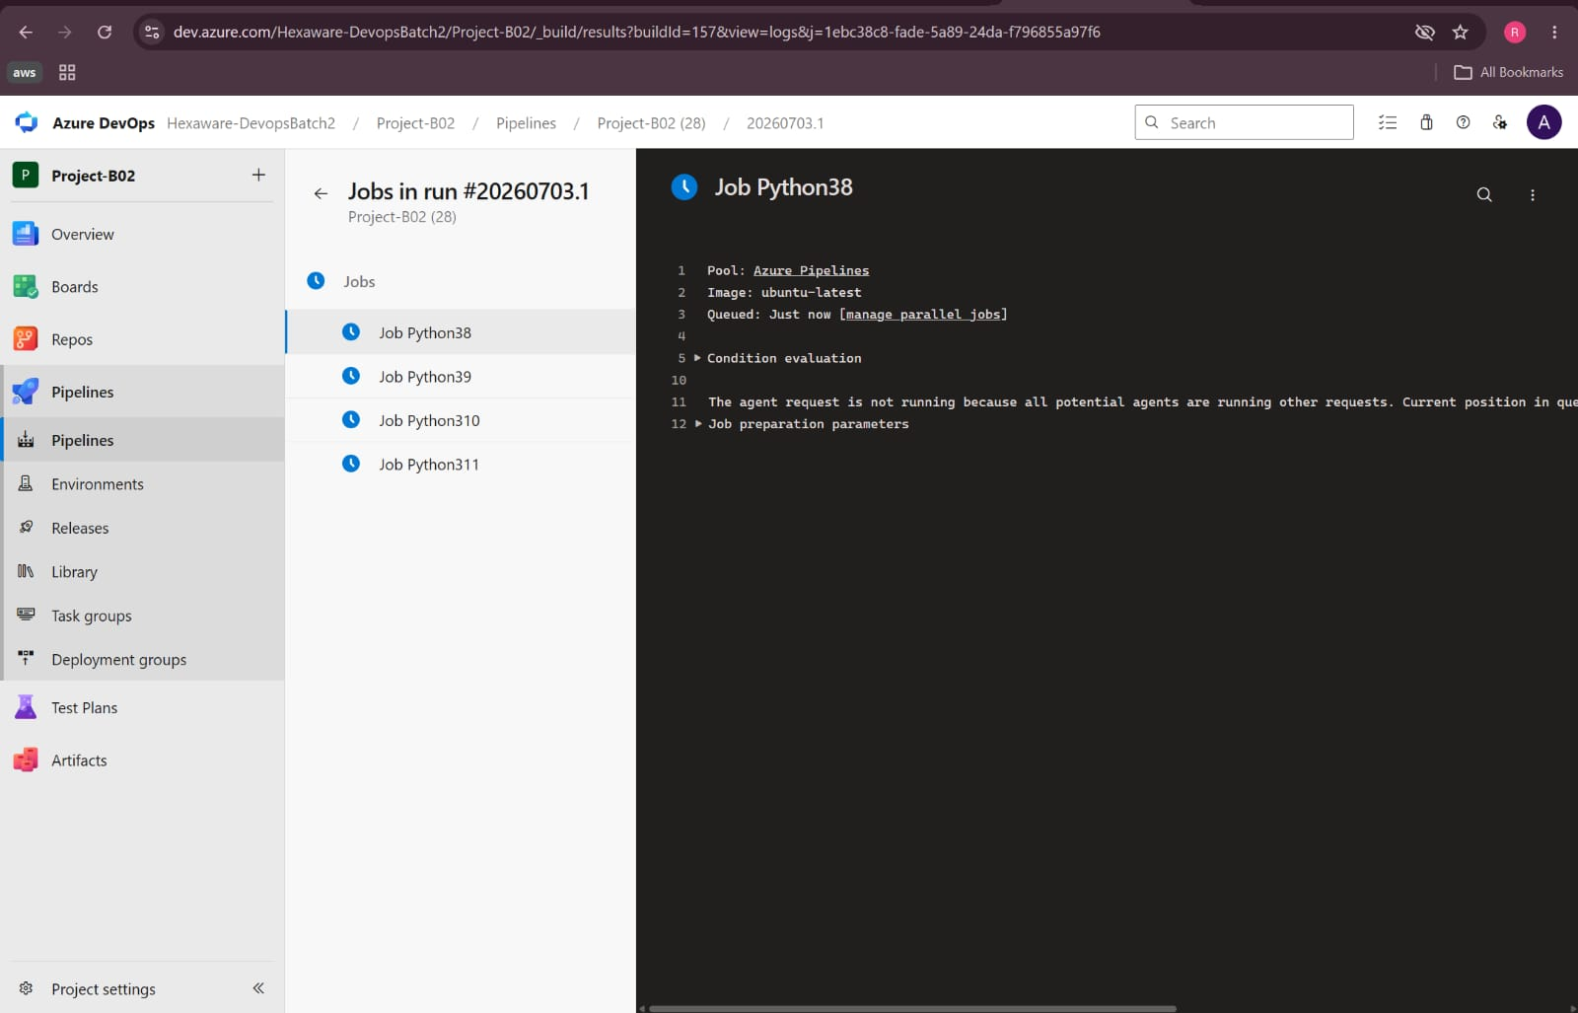

User Story 3
As a user, I want to update and delete customer records so that the information remains accurate and up to date.
Tasks
- Implement the Update Customer functionality.
- Implement the Delete Customer functionality.
- Verify update and delete operations.
- Perform final testing.

Part 2 – Azure DevOps Repository Structure
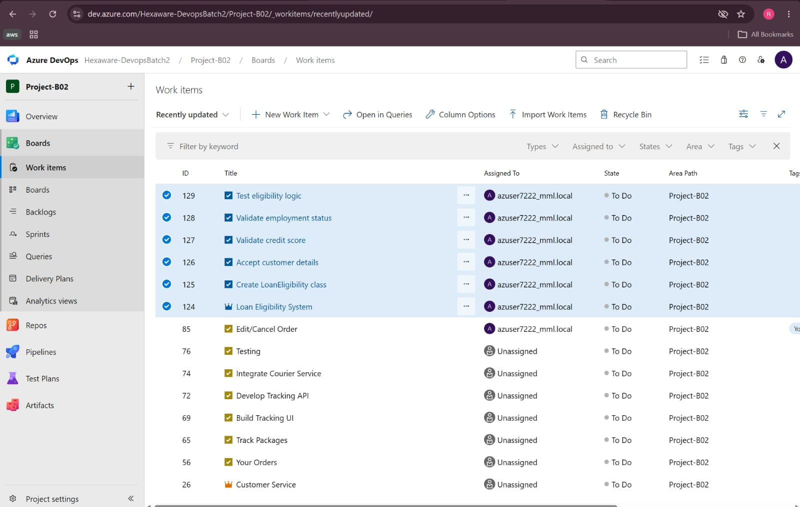

customer-management-system/
│
├── app.py
├── requirements.txt
└── azure-pipelines.yml

Part 3 – Azure DevOps YAML CI Pipeline
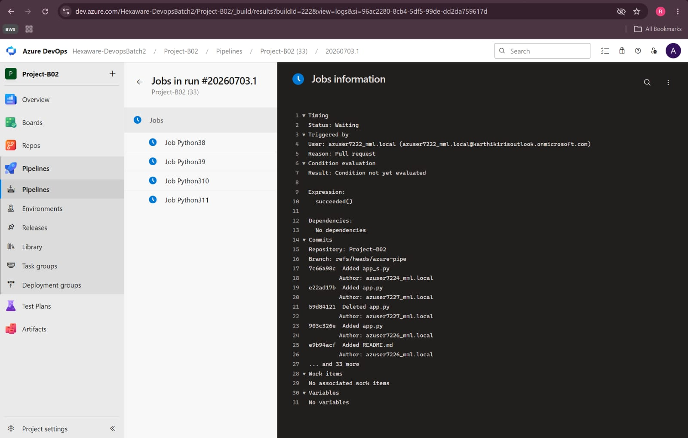

trigger:
- main

pool:
vmImage: 'ubuntu-latest'

steps:

- task: UsePythonVersion@0
inputs:
versionSpec: '3.x'

- script: |
python --version
displayName: 'Check Python Version'

- script: |
pip install -r customer-management-system/requirements.txt
displayName: 'Install Dependencies'

- script: |
python customer-management-system/app.py
displayName: 'Run Python Application'

Pipeline Workflow
Developer Pushes Code
│
▼
Trigger (main branch)
│
▼
Checkout Source Code
│
▼
Use Python Version (3.x)
│
▼
Check Python Version
│
▼
Install Dependencies
│
▼
Run Python Application
│
▼
Build Successful
│
▼
Application Output Displayed in Pipeline Logs

Expected Pipeline Output
Python
Customer Details
Customer ID : 101
Customer Name : Rahul Sharma

Build completed successfully.

Validation Checklist
- Azure DevOps Project created.
- Agile Boards contain Epic, Features, User Stories, and Tasks.
- Git repository contains the Python application.
- YAML pipeline is configured successfully.
- CI pipeline executes without errors.
- Python application output is displayed in the pipeline logs.
- All required screenshots are captured for submission.

Capstone_project – 1:
Capstone Project: Azure DevOps CI Pipeline for a Python Application
Business Scenario
A retail company wants to automate its Python application deployment process using Azure DevOps. As part of its modernization initiative, the engineering team has adopted Agile planning and Continuous Integration (CI). The objective of this project is to plan the work using Azure DevOps Boards, manage the source code using Azure Repos, and create a CI pipeline that automatically builds and validates the Python application whenever changes are committed.

Objective
The objectives of this project are:
- Create Agile work items using Azure DevOps Boards.
- Develop a simple Python application.
- Store the application in an Azure DevOps Git repository.
- Create an Azure DevOps YAML pipeline.
- Automatically build and execute the application.
- Validate that the pipeline executes successfully.

Part 1 – Agile Planning
Epic
Develop a Customer Management System for a Retail Company
Description
Develop a Python application that enables users to manage customer records by adding, viewing, updating, and deleting customer information.

Feature 1 – Customer Registration
User Story
As a user, I want to add new customers so that customer information can be stored in the system.


Tasks
- Create the Customer class.
- Implement Add Customer functionality.
- Validate customer details.
- Test customer creation.

Feature 2 – Customer Information Management
User Story
As a user, I want to view customer details so that I can access stored customer information.
Tasks
- Implement View Customer functionality.
- Display customer information.
- Test the view operation.

Feature 3 – Customer Maintenance
User Story
As a user, I want to update and delete customer information so that customer records remain accurate.
Tasks
- Implement Update Customer functionality.
- Implement Delete Customer functionality.
- Test update operation.
- Test delete operation.

Part 2 – Source Code Management
Azure DevOps Repository Name
customer-management-system

Project Structure
customer-management-system/
│
├── app.py
├── requirements.txt
├── azure-pipelines.yml
└── README.md
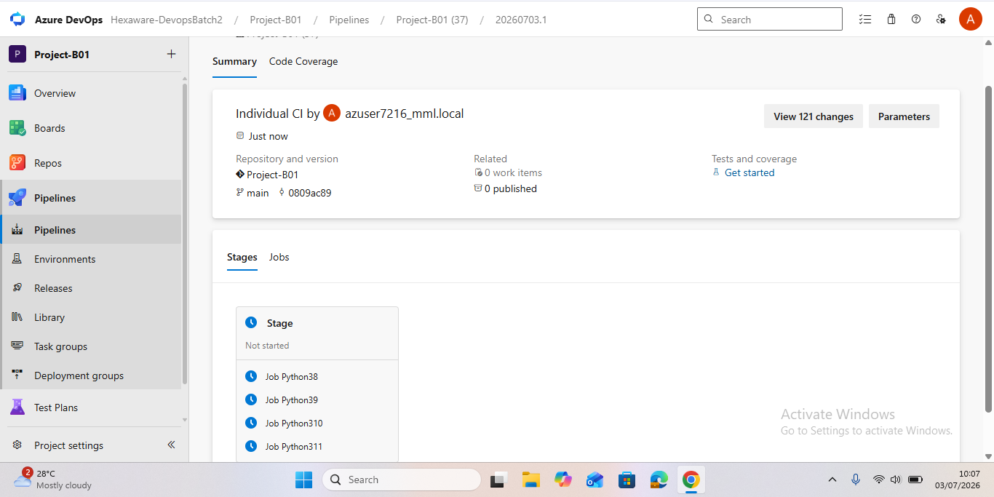

Python Source Code (app.py)
class Customer:

def __init__(self, customer_id, name):
self.customer_id = customer_id
self.name = name

def display(self):
print("Customer Details")
print("----------------")
print(f"Customer ID : {self.customer_id}")
print(f"Customer Name : {self.name}")

customer = Customer(101, "Rahul Sharma")
customer.display()
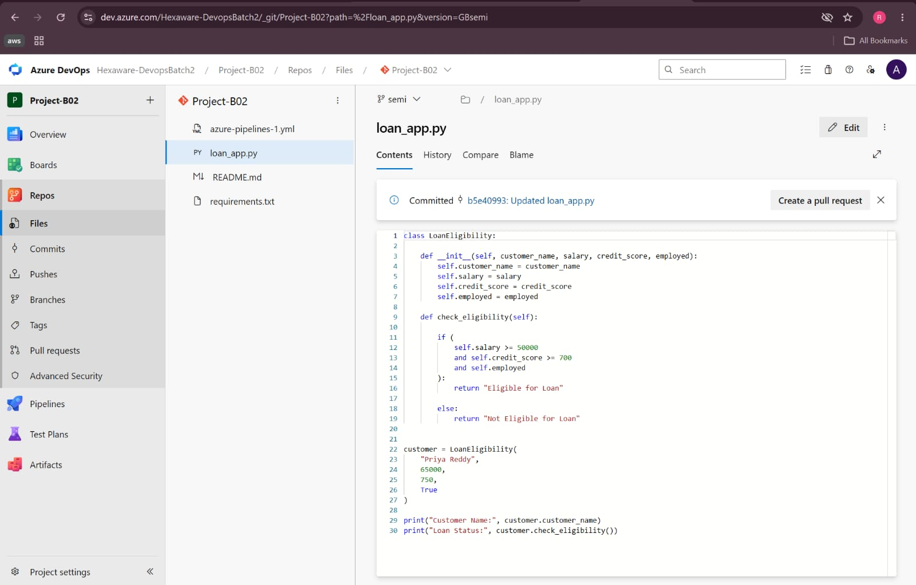

requirements.txt
# No external dependencies

Part 3 – Continuous Integration (CI)
Azure DevOps YAML Pipeline
trigger:
- main

pool:
vmImage: 'ubuntu-latest'

steps:

- task: UsePythonVersion@0
inputs:
versionSpec: '3.x'

- script: |
python --version
displayName: 'Check Python Version'

- script: |
pip install -r customer-management-system/requirements.txt
displayName: 'Install Dependencies'

- script: |
python customer-management-system/app.py
displayName: 'Run Python Application'

CI Pipeline Workflow
Developer Pushes Code
│
▼
Repository (Azure Repos)
│
▼
Trigger (main branch)
│
▼
Checkout Source Code
│
▼
Use Python Version (3.x)
│
▼
Check Python Version
│
▼
Install Dependencies
│
▼
Run Python Application
│
▼
Build Successful
│
▼
Application Output Displayed in Pipeline Logs

Expected Pipeline Output
Python
Customer Details
Customer ID : 101
Customer Name : Rahul Sharma
Build completed successfully.

Part 4 – Validation
The following validations were successfully completed:
- The Azure DevOps project was created successfully.
- Agile work items (Epic, Features, User Stories, and Tasks) were created in Azure DevOps Boards.
- The Git repository contains the Python application source code.
- The YAML pipeline was created successfully.
- The CI pipeline executed successfully without errors.
- The Python application output was displayed in the pipeline logs.
Conclusion
The Customer Management System project was successfully implemented using Azure DevOps.

